Broadclyst Primary School
School Lane, Broadclyst, Exeter EX5 3JG
01392 304040
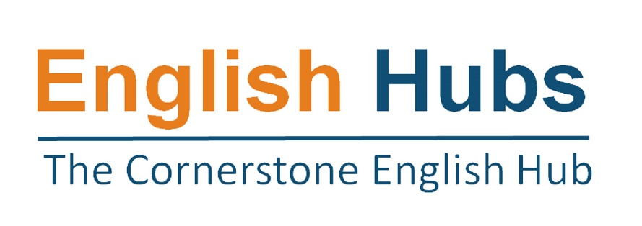
English Hub Self-Referral Form
English Hubs: facilitating excellent teaching of reading and early language in reception and Key Stage 1.
We are delighted that you are interested in the support in early language and reading teaching that we are offering as an English Hub school. Our aim in 2022/23 is to provide high quality insight and advice to enable you to develop your own excellent practice in teaching reading through systematic synthetic phonics and early language and encouraging a love of reading among your pupils. It is also to provide support through events, audits and financial support for schools that have struggled to maintain their provision.
The support that we can offer includes:
- Attending a showcase of best practice in the teaching of early language and reading through systematic synthetic phonics.
- help developing your own action plan for improving teaching of early language and reading.
- financial support to buy resources that you have identified in your action plan.
- A detailed in-school audit of your teaching provision, for those schools that would most benefit.
Please provide as much information below as possible. We will use this to prioritise among schools where there are more applications than we can accommodate.
- School name
- Address
- Website
URN
Number of pupils on roll for reception and Key Stage 1.
Phonics Screening Check scores for the last three years. | 2018 | 2019 | 2022
Any relevant contextual information about your PSC scores.
- Key Stage 1 Reading assessment scores.
- Current Phonics Programme(s) and desired programme if changing
- Percentage of children eligible for the pupil premium in the school.
Is your school in an Opportunity Area?
- Most recent Ofsted inspection grade and any additional points of relevance.
- Please outline any other support that you are currently receiving in early language or literacy.
- In what ways has the early reading provision in your school been impacted by the recent COVID-19 pandemic?
- Please briefly describe what you hope to achieve as a result of the support from an English Hub.
- Headteacher’s signature

